CSD325-T301 Advanced Python | Date : July 19, 2026
Module 6.2 Assignment: Forest Fire Simulation - Program and Revised Flowchart
Group-A | Rakesh Shrestha | Brandon Cox | Jerrold Icban | Christian Thompson
Overview: The flowcharts below model the program forestfiresim_325.py. This is a brownfield update of our Module 5 forest fire simulation: after the forest grid is built, a lake is carved into the center of the display (Figure 6). The lake is drawn in blue and can never be modified once placed, so it works as a permanent firebreak that flames cannot cross. Figures 2, 3, and 4 below have been revised to show where the lake is added, displayed, and protected; Figures 1 and 5 did not need to change.
Figure 1 – Main Program Flow (main) – unchanged

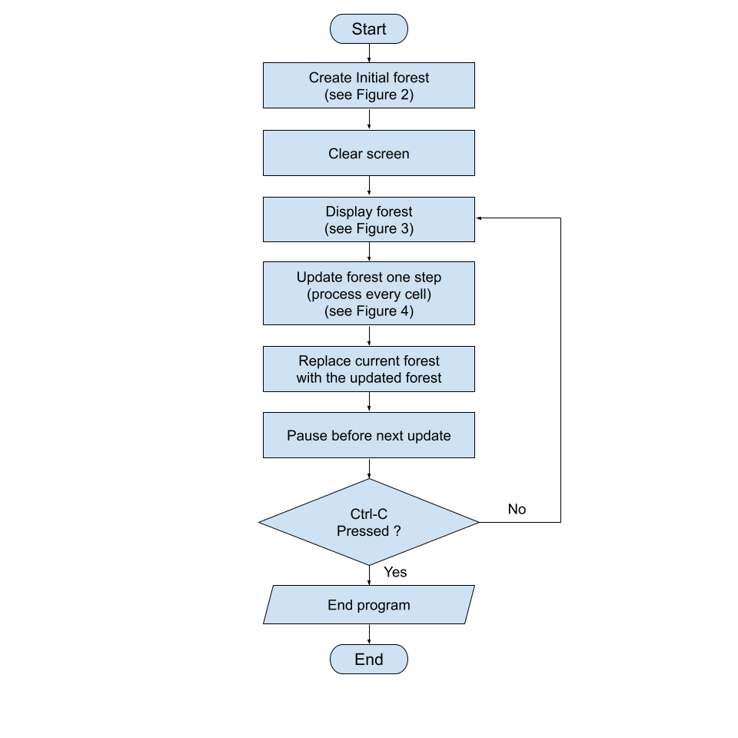

Figure 2 – Create Initial Forest (createNewForest) – revised: lake added before return

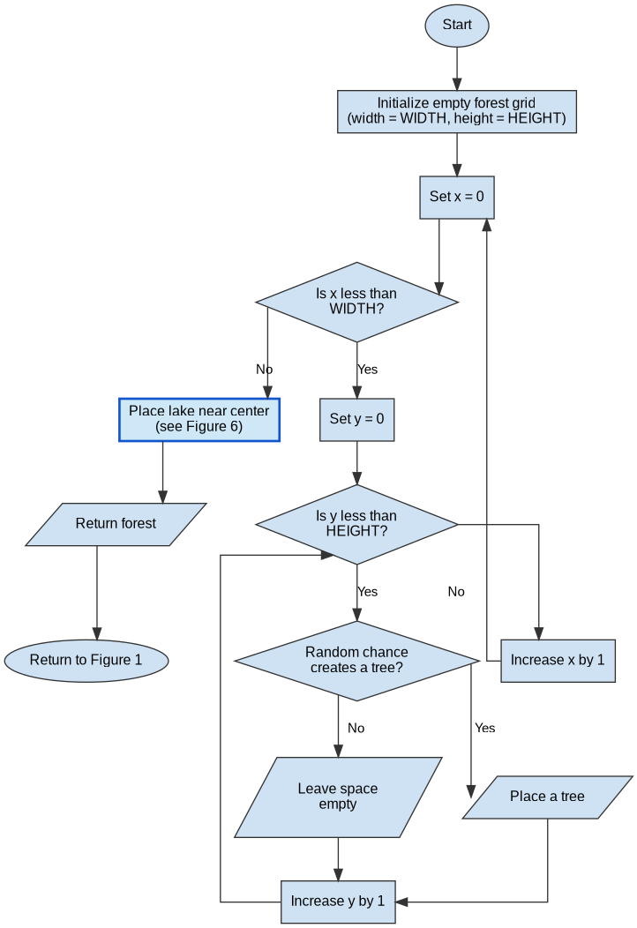

Figure 3 – Display Forest ( displayForest ) – revised: water displayed in blue

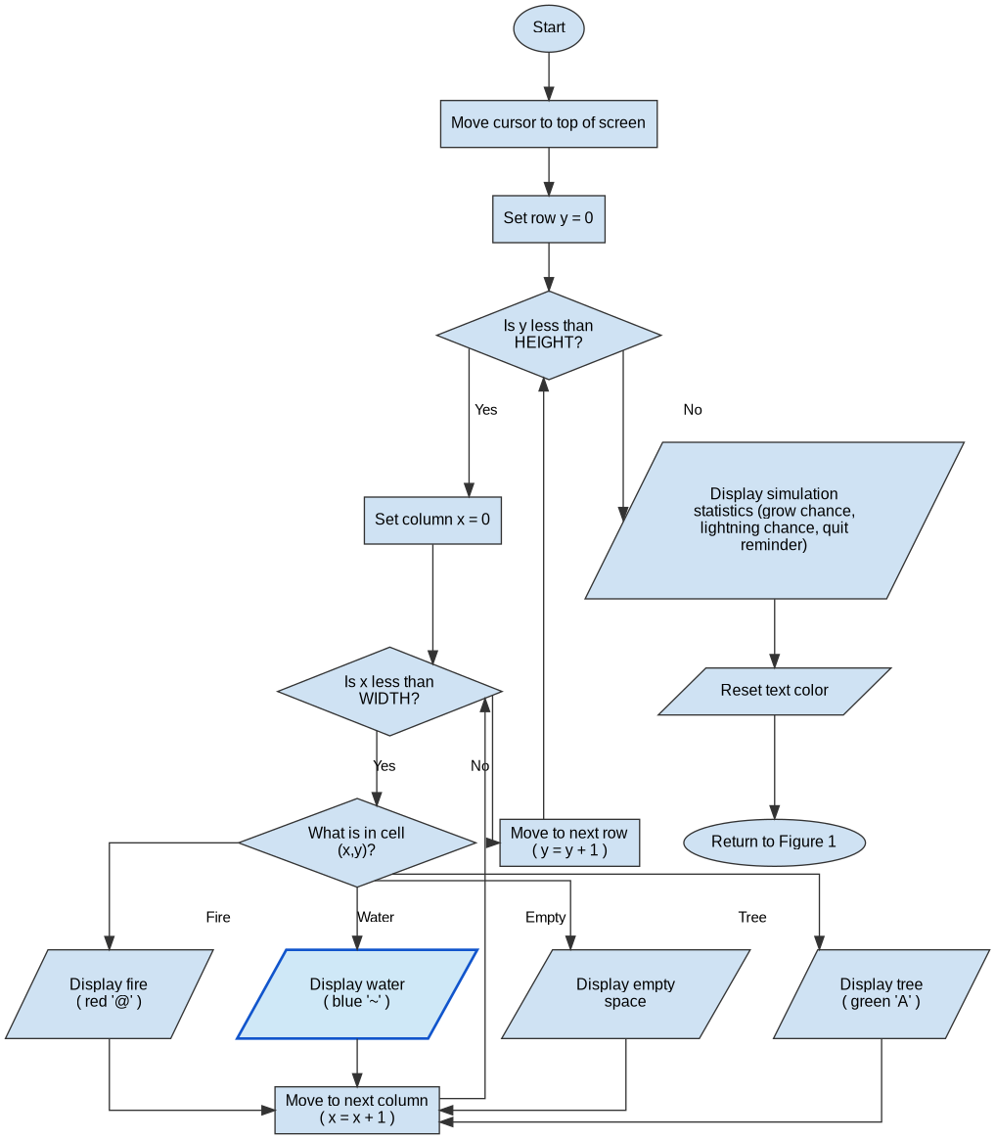

Figure 4 – Update One Cell ( Process Cell Logic ) – revised: water check added first

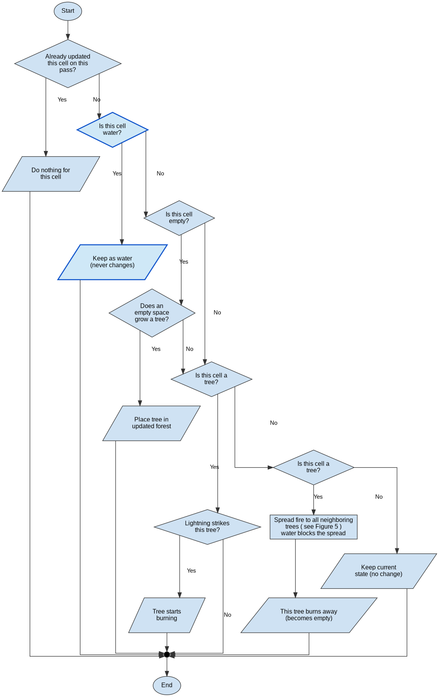
Figure 5 – Spread Fire to Neighboring Trees ( called from Figure 4 ) – unchanged

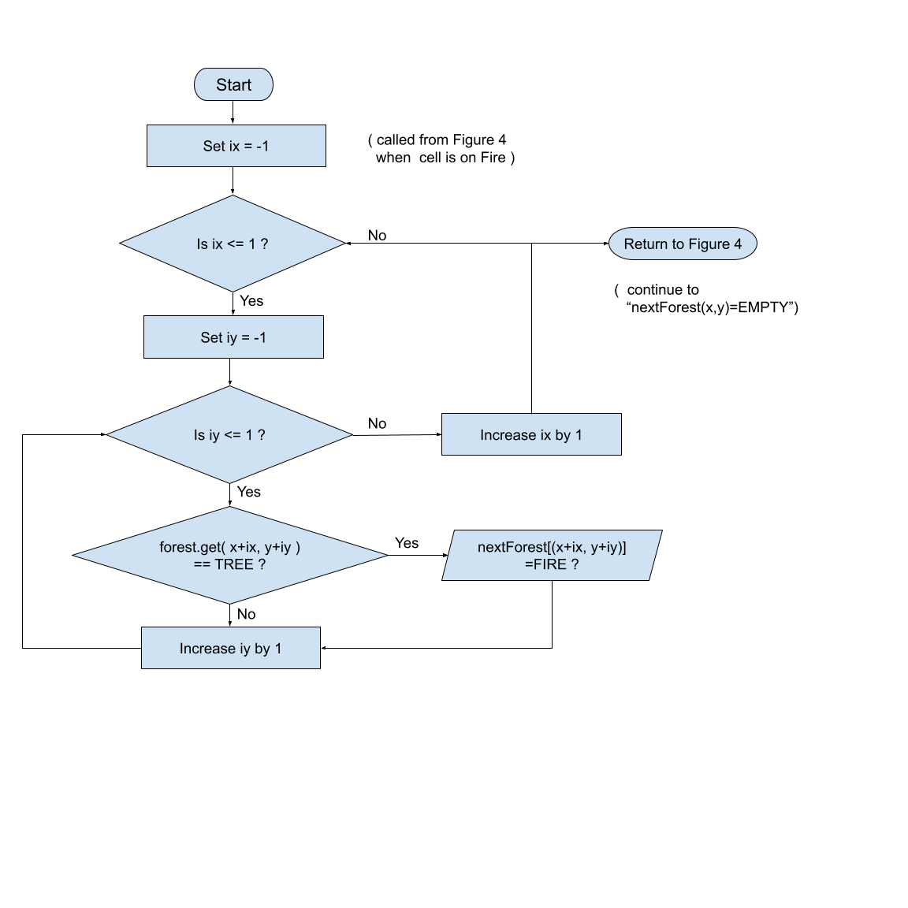
Note: This logic already only spreads fire to a neighbor when that neighbor is a tree, so a water cell is skipped automatically. No changes were needed here for the lake to work as a firebreak.

Figure 6 – Place Lake (addLake) – new, called from Figure 2

